Namespace lab:

kubectl get namespaces

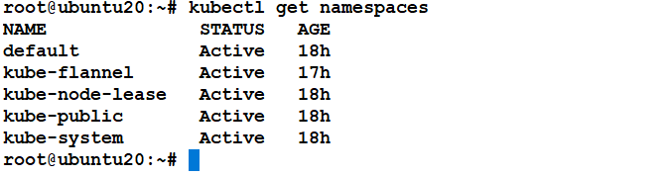

kubectl describe namespaces default

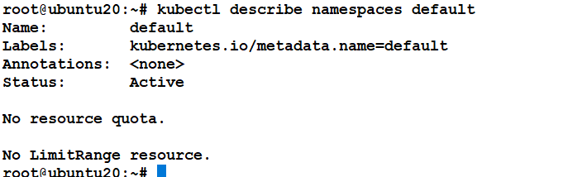

kubectl create namespace test

kubectl describe namespace test

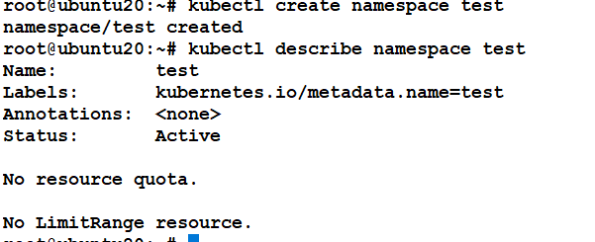

Create namespace using yaml

apiVersion: v1

kind: Namespace

metadata:

name: amit

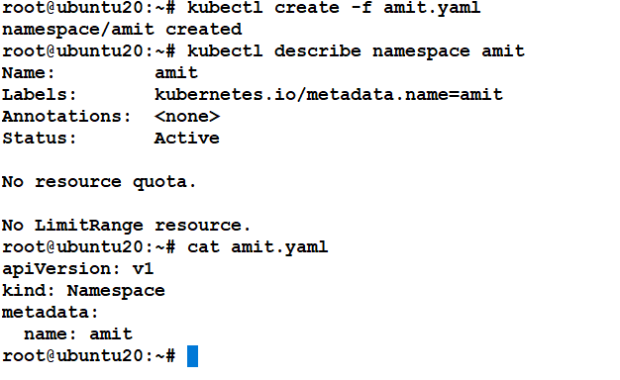

Create ResourceQuota object for namespace, create yaml file

apiVersion: v1

kind: ResourceQuota

metadata:

name: mem-cpu-demo

spec:

hard:

requests.cpu: "1"

requests.memory: 1Gi

limits.cpu: "2"

limits.memory: 2Gi

*kubectl create -f mem-cpu-quota.yaml --namespace=test*

*kubectl describe namespace test*

